CLOUD COMPUTING LAB


SUBMITTED TO
SIR WAQAS & ENGR. SHOAIB

SUBMITTED BY
HAMNA MAHMOOD
2023-BSE-025
BSE V-A

Lab 14 – Terraform + Ansible: Dynamic Inventory, Roles & Automated Nginx/PHP & Docker Deployment
Task 0 – Lab Setup (Codespace & GH CLI)
- task0_codespace_open.png
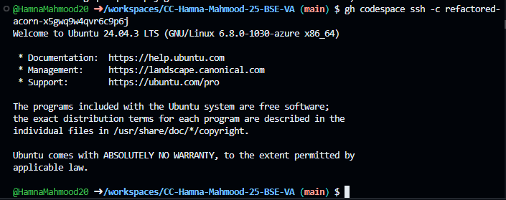
- task0_env_check.png
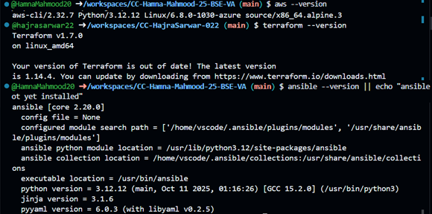
- task0_aws_config.png
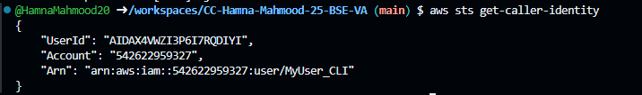
Task 1 – Generate SSH key & Initial Terraform
- task1_ssh_keygen_before.png
- task1_ssh_keygen.png
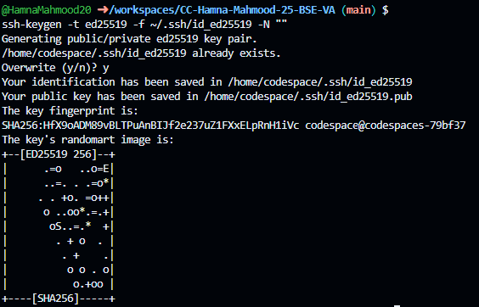
- task1_ssh_keygen_after.png
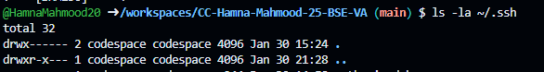
- task1_terraform_tfvars_created.png
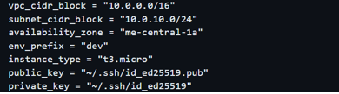
- task1_terraform_init.png
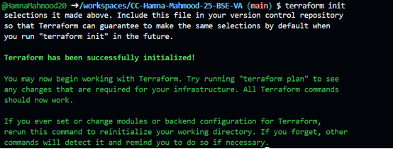
- task1_terraform_apply_2_instances.png
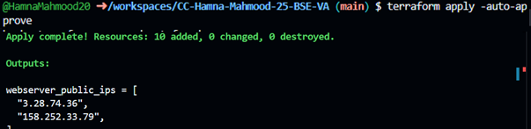
- task1_terraform_output_ips.png
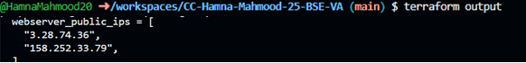
Task 2 – Static ansible inventory with 2 instances
- task2_ansible_install.png
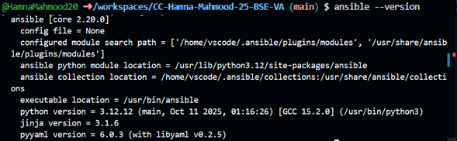
- task2_terraform_output_ips.png
- task2_hosts_created.png
- task2_ansible_ping_initial.png
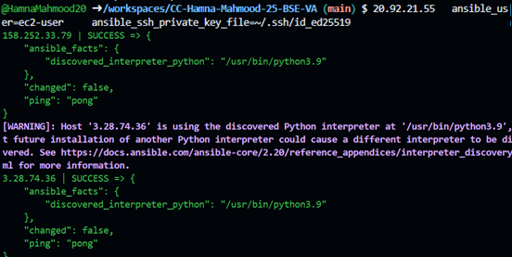
- task2_hosts_with_common_args.png
- task2_ansible_ping_success.png
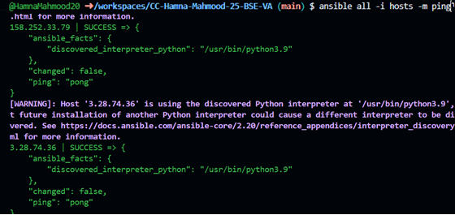
Task 3 – Scale to 3 instances & group based inventory
- task3_terraform_apply_3_instances.png
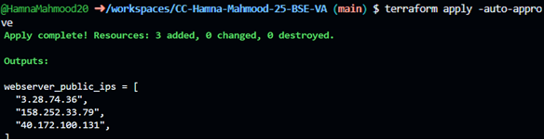
- task3_terraform_output_3_ips.png
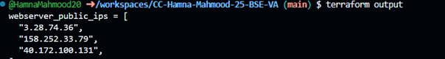
- task3_ansible_single_ip_ping.png
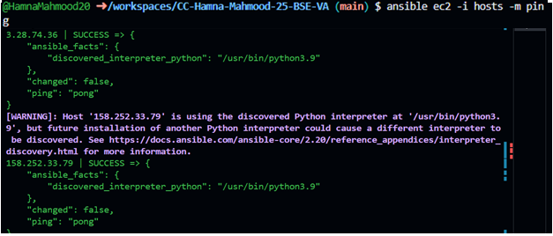
- task3_ansible_droplet_ping.png
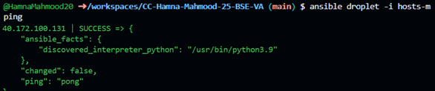
- task3_ansible_all_ping.png
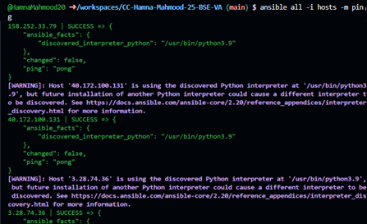
Task 4 – Global Ansible.cfg & first nginx playbook
- task4_global_ansible_cfg.png
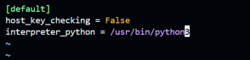
- task4_my_playbook_created.png
- task4_ansible_play_ec2.png
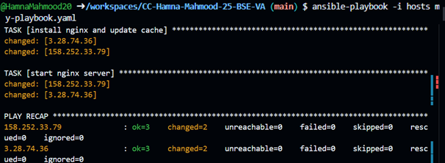
- task4_nginx_browser_ec2.png
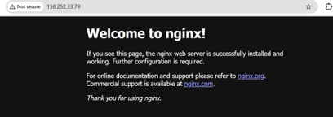
- task4_my_playbook_droplet.png
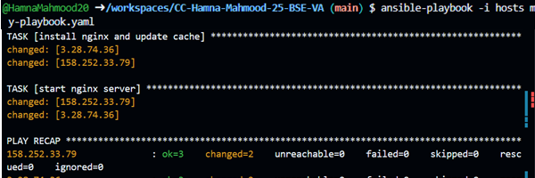
- task4_nginx_browser_droplet.png
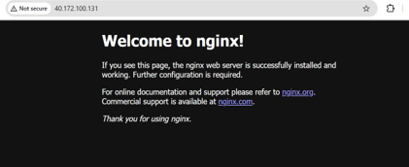
Task 5- Single Nginx Target Group
- task5_project_ansible_cfg_created.png
- task5_project_ansible_cfg.png
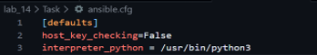
- task5_main_tf_count_1.png
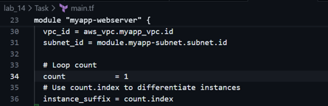
- task5_terraform_output_single_ip.png
- task5_my_playbook_nginx_group.png
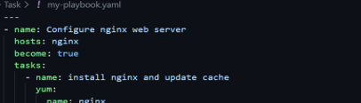
- task5_ansible_play_nginx_group.png
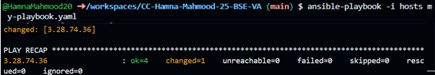
- task5_nginx_browser_single.png
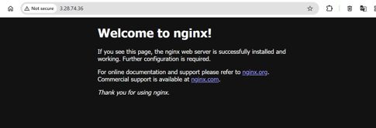

Task 6- Ansible Managed SSL
- task6_my_playbook_ssl_section.png
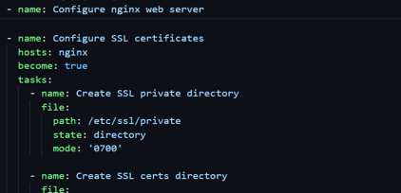
- task6_ansible_play_ssl.png
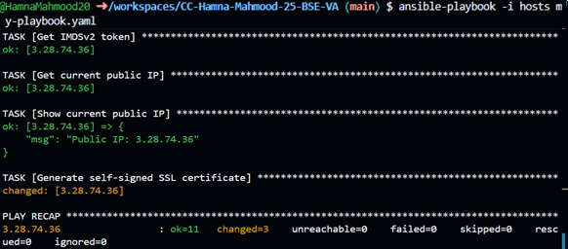
- task6_ssl_cert_file.png
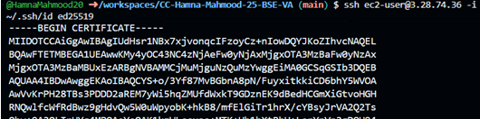
- task6_ssl_key_file.png
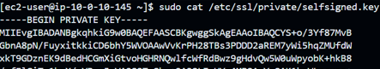

Task 7 – PHP Frontend Deployment with Templates
- task7_files_templates_created.png
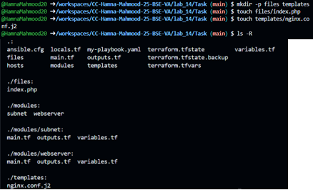
- task7_my_playbook_web_deploy.png
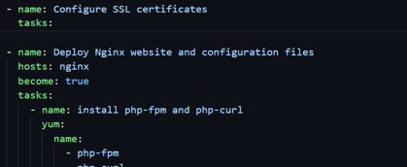
- task7_ansible_play_web_deploy.png
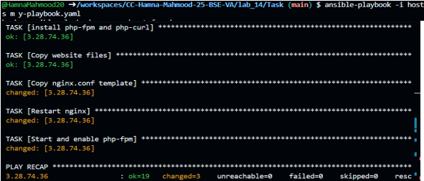
- task7_php_https_browser.png
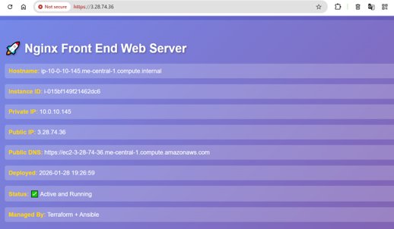
Task 8 – Docker & Docker Compose
- task8_terraform_apply_docker_instance.png
- task8_terraform_output_new_ip.png
- task8_hosts_docker_servers.png
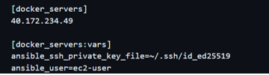
- task8_my_playbook_docker.png
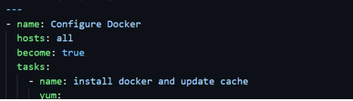

- task8_ansible_play_docker.png
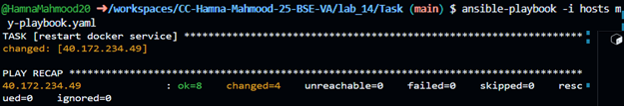
- task8_docker_ps_remote.png
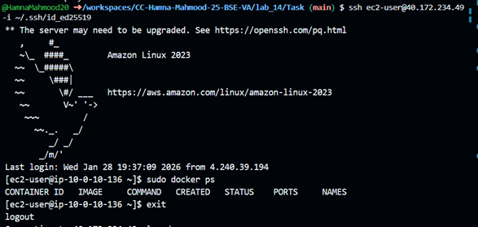
Task 9 – Gitea Docker
- task9_my_playbook_add_user_to_docker.png
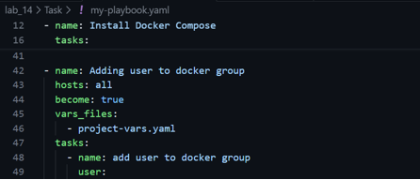
- task9_my_playbook_deploy_containers.png
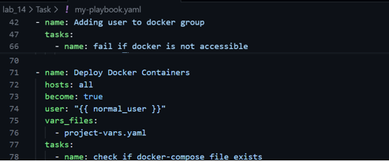
  - task9_compose_yaml.png
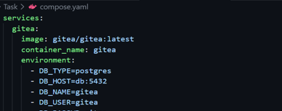
- task9_ansible_play_gitea.png
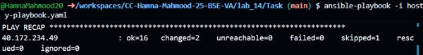
- task9_sg_ingress_3000.png
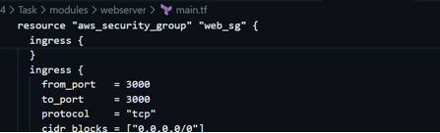
- task9_terraform_apply_sg_3000.png
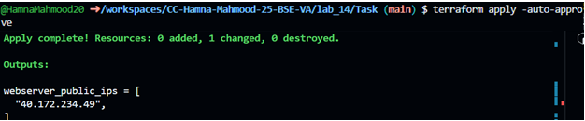
- task9_gitea_browser.png
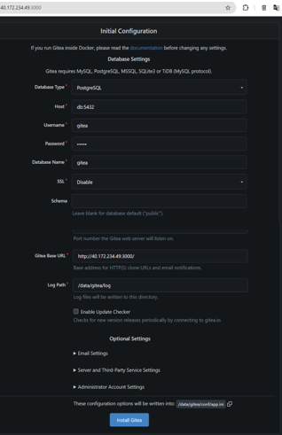
Task 10 – Automating Ansible
- task10_null_resource_main_tf.png
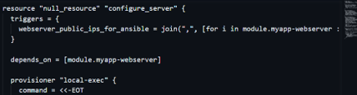
- task10_terraform_destroy_before_null.png
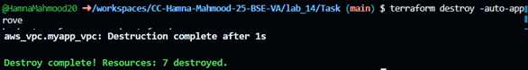
- task10_terraform_apply_with_local_exec.png
